# Lab Exercise 1(Video Link: http://youtu.be/H8mxhmPvaEE?hd=1)

1.Login to <https://technet.microsoft.com/en-us/virtuallabs>

2.Select “SharePoint Server 2013” under “SharePoint Server”

3. Select “Overview of IT Professional Features in SharePoint Server 2013”

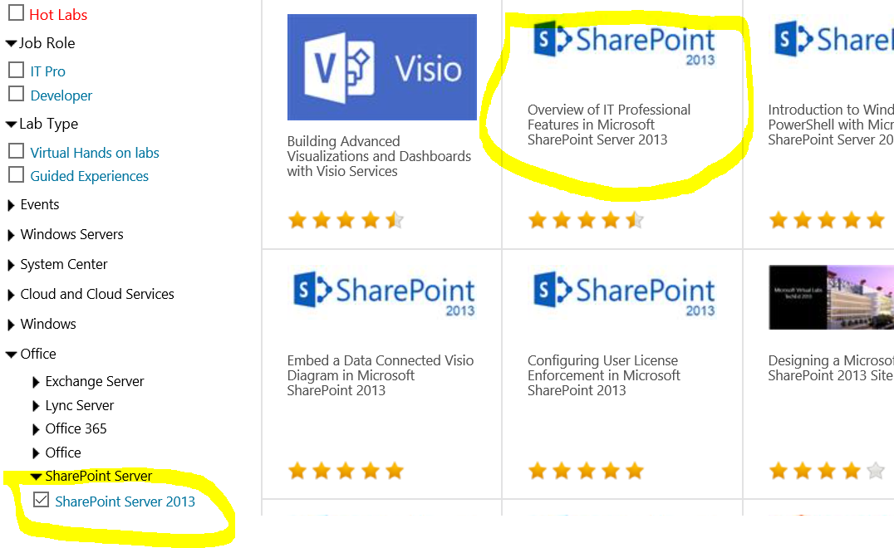

4. Select “Get Started”

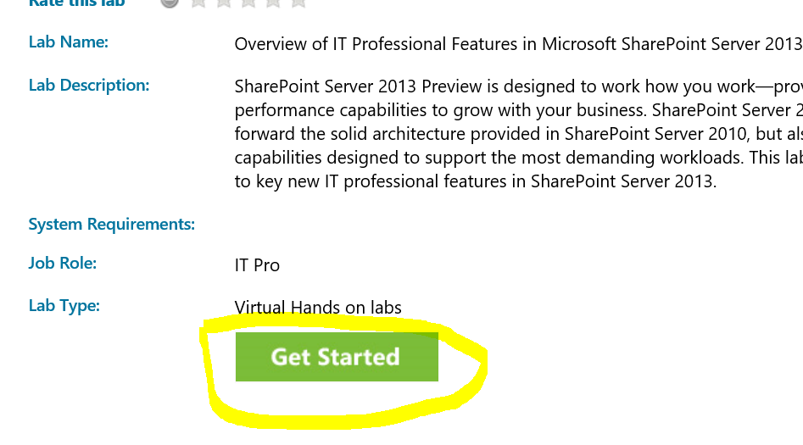

5. The lab opens in a new window. Click “Launch Lab”

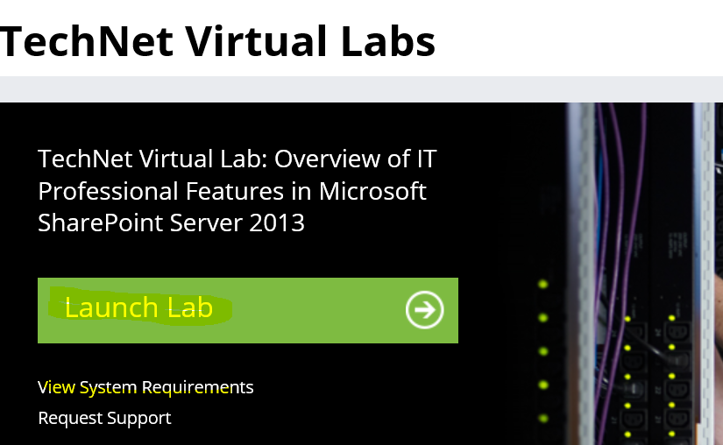

6. Enter your Microsoft Live ID

Example: [abc@outlook.com](mailto:abc@outlook.com)

7. The lab launches.

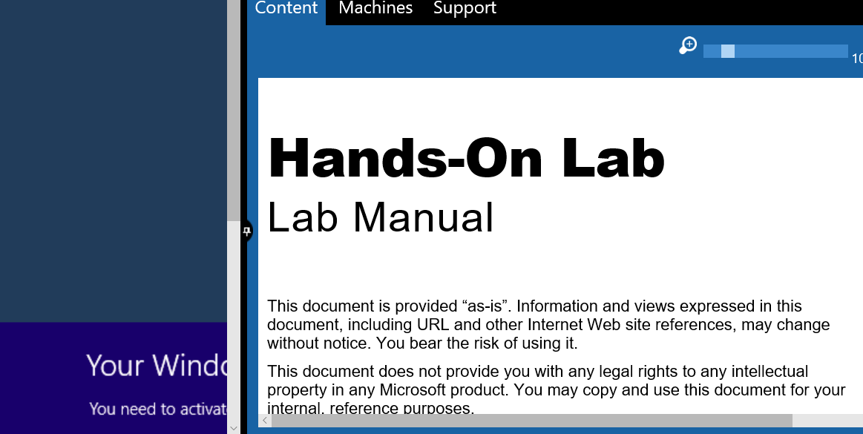

8. Under Machines tab, select “w15-sp” and login using “Administrator” ID.You can paste UserName and Password using Command button at top

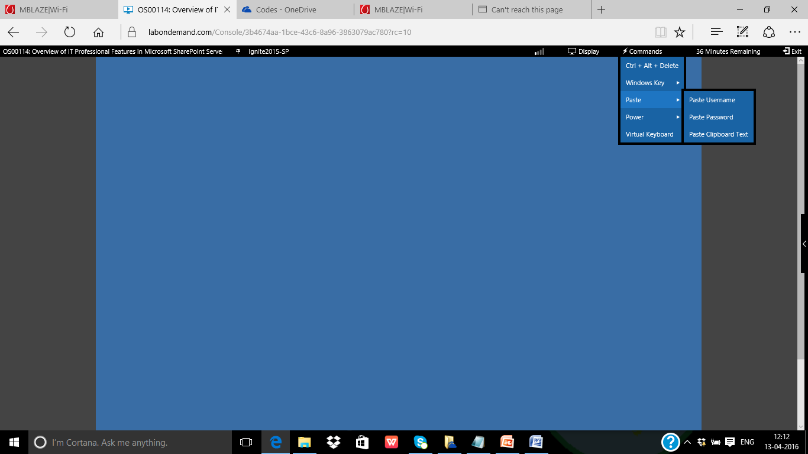

9. Open Internet Explorer and Type https://<>.sharepoint .com

## Lab Exercise 1 : Launch Central Administration

1. Start->Programs->Microsoft SharePoint 2013 Products -> Central Administration
2. 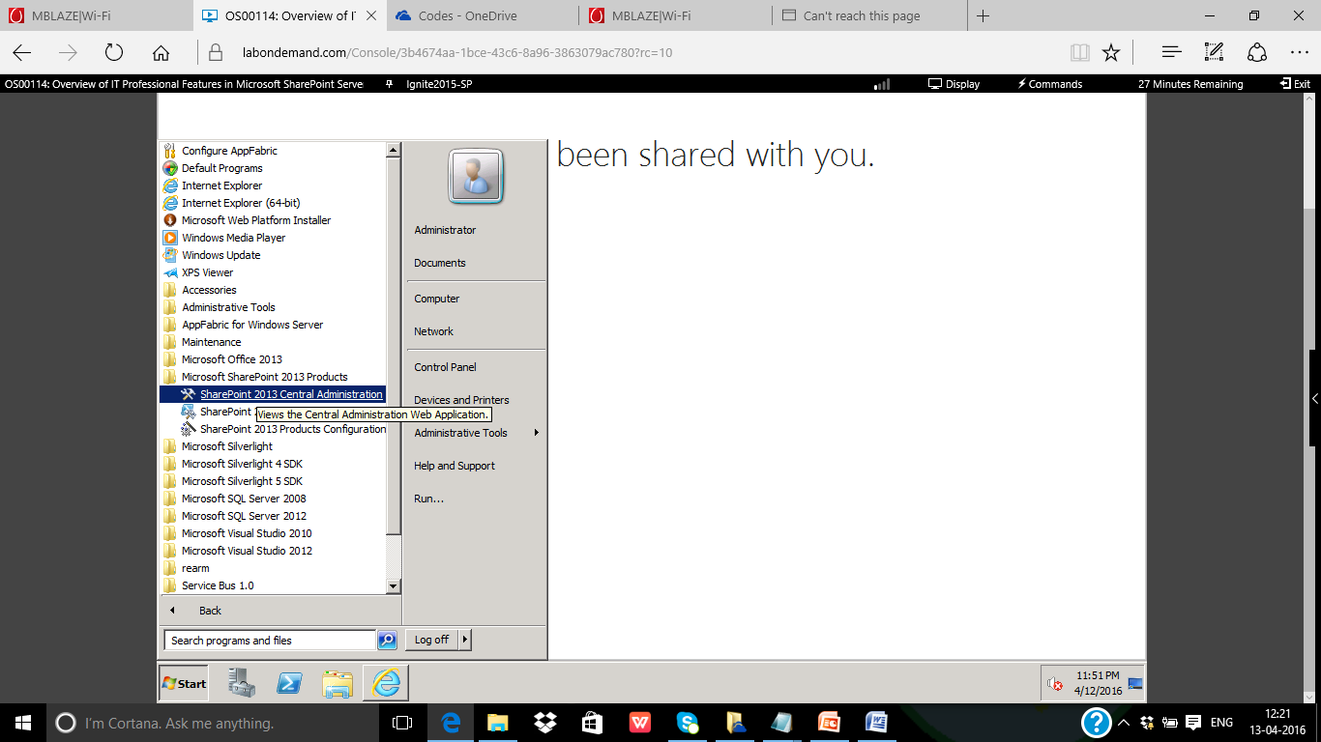
3. 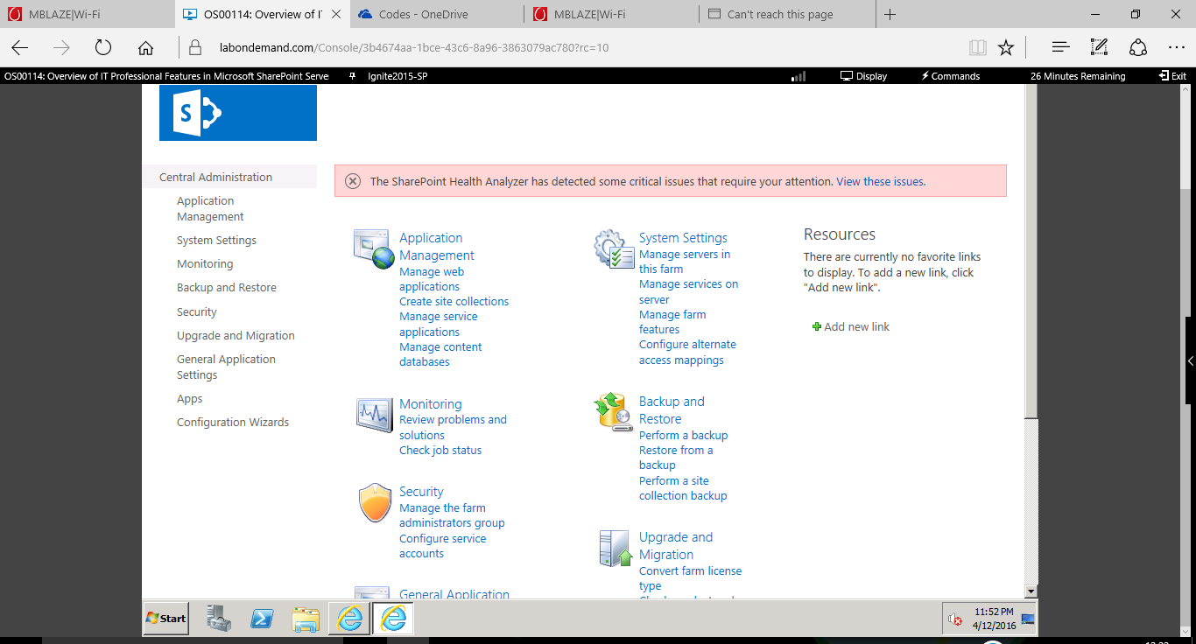

## Lab Exercise 2:Create Site Collection

1. Click Manage Web Applications -> Create Site Collection
2. Choose “intranet.contoso.com” and type Demo for “Title” and URL
3. 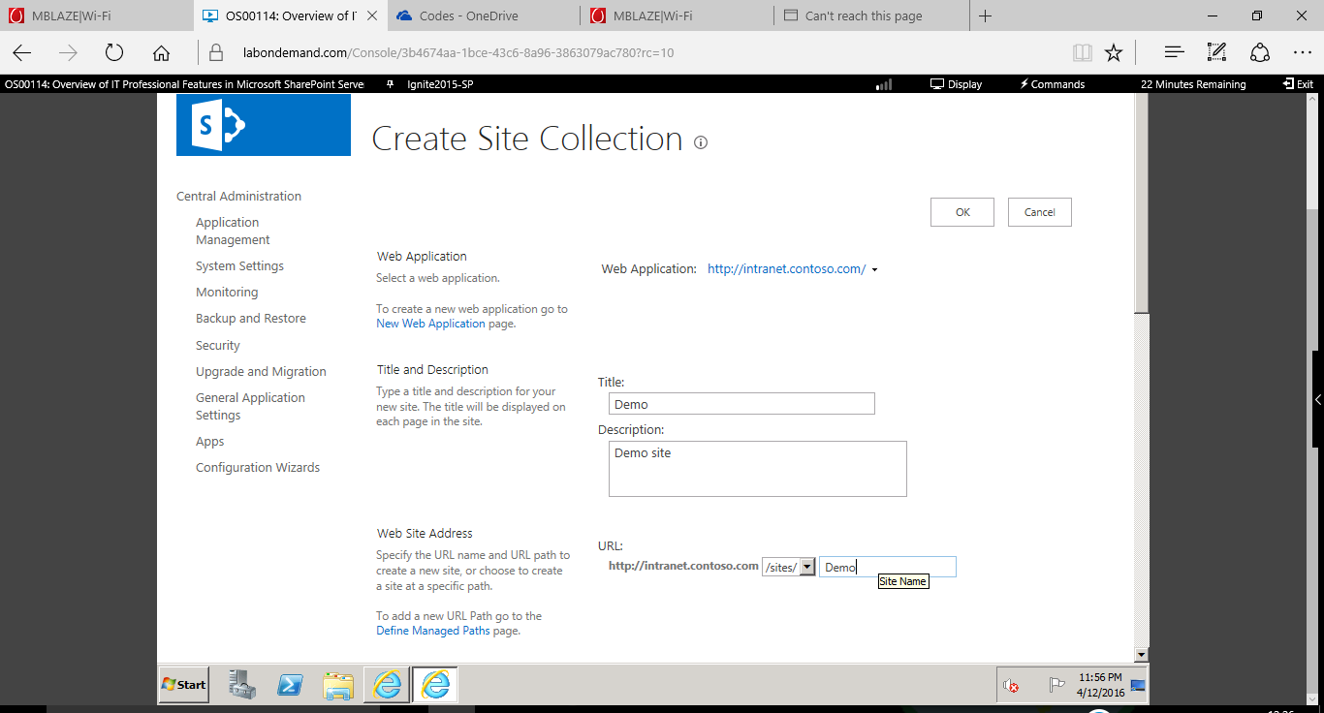 Choose “Developer Site Template”
4. Click “OK”
5. Open <http://intranet.contoso.com/sites/Demo>
6. View Site Contents
7. Create a Web Part Page and add/explore web part.